# Unit 2 Assignment: Practice Exercises

# Amon-ra

# Herzing University

BU 624-7 Systems Analysis and Design

* Weekly topics:  Expected time for activities/ Outline of an information systems plan

I:  Time estimates (10 points)

Calculate the expected time for the following activities.

              Expected Time = (Optimistic Time + (4 * Most Likely Time) + Expected Time) /6

| Activity | Optimistic Time | Most Likely Time | Pessimistic Time | Expected Time |
| --- | --- | --- | --- | --- |
| A | 3 | 7 | 11 | 7 |
| B | 5 | 9 | 13 | 9 |
| C | 1 | 2 | 9 | 3 |
| D | 2 | 3 | 16 | 5 |
| E | 2 | 4 | 18 | 6 |
| F | 3 | 4 | 11 | 5 |
| G | 1 | 4 | 7 | 4 |
| H | 3 | 4 | 5 | 4 |
| I | 2 | 4 | 12 | 5 |
| J | 4 | 7 | 9 | 6.8 |

II:  Project diagrams (20 points)

A project has been defined to contain the following list of activities along with their required times for completion.

| Activity No. | Immediate Activity | Time (weeks) | Predecessors |
| --- | --- | --- | --- |
| 1 | Collect requirements | 3 |  |
| 2 | Analyze processes | 2 | 1 |
| 3 | Analyze data | 2 | 2 |
| 4 | Design processes | 6 | 2 |
| 5 | Design data | 3 | 3 |
| 6 | Design screens | 2 | 3,4 |
| 7 | Design reports | 4 | 4,5 |
| 8 | Program | 5 | 6,7 |
| 9 | Test and document | 7 | 7 |
| 10 | Install | 2 | 8,9 |

Specific tasks for exercise II project diagrams.

1. Draw a network diagram for the activities.

Collect Requirements

Activity #1 Time 3 wk

v

Analyze processes

Activity #2 Time 2 wk

v

Analyze data

Activity #3 Time 2 wk

v

Design processes

Activity #4 Time 6 wk

v

Design data

Activity #5 Time 3 wk

v

Design screens

Activity #6 Time 2 wk

v

Design reports

Activity #7 Time 4 wk

v

Program

Activity #8 Time 5 wk

v

Test and document

Activity #9 Time 7 wk

v

Install

Activity #10 Time 2 wk

v

1. Construct a Gantt chart for the project.

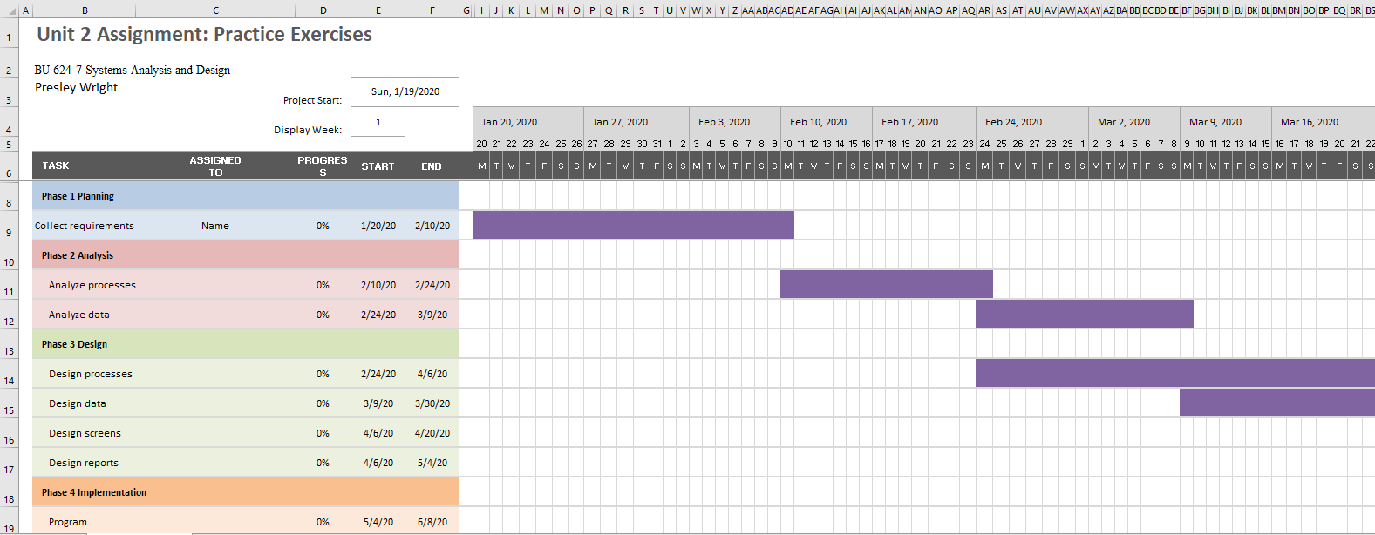

1. Calculate the earliest expected completion time.
   1. August 10, 2020
2. Show the critical path. (See chart on next page)
3. Collect requirements
4. Analyze processes
5. Analyze data
6. Design processes
7. Design data
8. Design screens
9. Design reports
10. Program
11. Test and document
12. Install

Collect Requirements

Activity #1 Time 3 wk

v

Analyze processes

Activity #2 Time 2 wk

v

Analyze data

Activity #3 Time 2 wk

v

Design processes

Activity #4 Time 6 wk

v

Design data

Activity #5 Time 3 wk

v

Design screens

Activity #6 Time 2 wk

v

Design reports

Activity #7 Time 4 wk

v

Program

Activity #8 Time 5 wk

v

Test and document

Activity #9 Time 7 wk

v

Install

Activity #10 Time 2 wk

v



III.  Preliminary outline of an information systems plan (20 points)

* Create a preliminary outline of an information systems plan.
* Choose a company that you are familiar with (or research one that you are not).
* Follow the “Outline of an information systems plan” shown in and complete a short information systems plan for the organization you chose.
* Write at least one brief paragraph for each of the seven categories in the outline.
  1. Organizational Mission
     + The Chris Draft Family Foundation is a nonprofit dedicated to “To strengthen communities by empowering families to live healthy lifestyles through a national movement of self-awareness and education.” (Chris Draft Family Foundation, n.d.)
  2. Informational Inventory
     + The company is a small operation with no enterprise-level equipment. The scope of inventory consists of personal laptops, desktops and phones. Its I.T. infrastructure relies on public Google cloud services such as Google Docs, Sheets Slides and Forms.
  3. Mission and Objectives of IS
     + The business needs to make a transition from Google Docs to a more efficient and effective information system. That needs to allow access from any and can be shared among the authorized personnel. Additionally it must come with a low price tag.
  4. Constraints
     + The company is without a dedicated I.T. team and lacks the equipment and space to accommodate an I.T. infrastructure. Any and all information system must take this into account. Furthermore, the information system must not require constant maintenance due to the lack of an I.T. staff.
  5. Long-Range IS Strategies
     + Leverage the power of cloud providers to create an infrastructure. Exam ways that the pay-for-what-you-use characteristic of the cloud, can be cost effective for the business. Explore the opportunities with new technology offered by the cloud can assist in giving the business an advantage.
  6. Short-Term Plan
     + Identify which cloud provider offers the best advantage for the business. Create cloud backups of critical information for better storage. Migrate from collected data in Google Sheets to an SQL database for better information, storage, processing and retrieval.
  7. Conclusions
     + The I.T. budget presently does not exist. Present I.T. related tasks are executed with no-cost solutions. Migrating solutions that offer better options features will create and expense for the company where there initially was no expense.

## References

Chris Draft Family Foundation (n.d.). Retrieved January 19, 2020, from http://www.chrisdraftfamilyfoundation.org/about

How to calculate expected duration, variance, and standard deviation of an activity. (n.d.). Retrieved January 19, 2020, from https://www.youtube.com/watch?v=_-rrXdPal8U

Valacich, J. S., & George, J. F. (2018). *Modern systems analysis and design*. Singapore: Pearson Education South Asia Pte Ltd.